Whaddya think these are ?

look closely and guess what they could be...
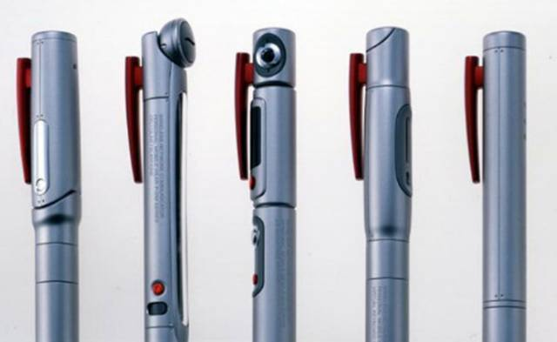
PENS WITH HIDDEN CAMS, Right?

Wrong!
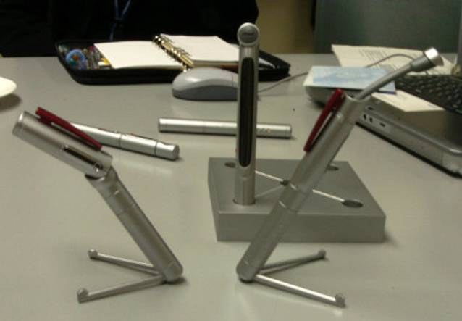
any wild guesses now?
ladies and gentlemen... congratulations! you've just seen the future of the lap top.
this will soon replace your PC
NOW SEE THIS...
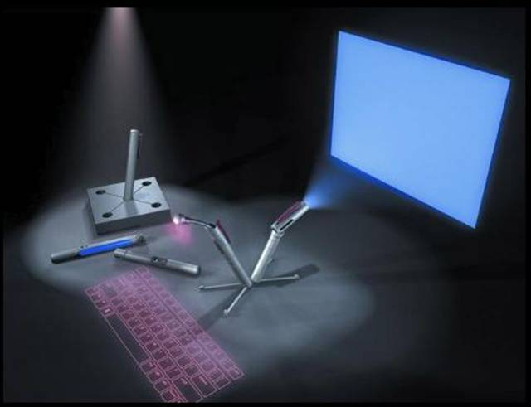
In the revolution of miniature computers, the scientists are ahead with bluetooth technology... 